Warmest Greetings dear family and friends,
The summer season will soon come to a close; fall is just around the corner bringing with it a transition of cooler weather and breathtaking autumn colors. So, too, are we in the midst of a transitional season in our lives. Our transition will take us from Southern California to Cuba in a matter of a few short months. We are humbled to announce that we have been appointed as mission co-workers to Cuba through the Presbyterian Mission Agency of the Presbyterian Church (U.S.A.). We are headed to the Seminario Evangélico de Teología (Evangelical Theological Seminary) in Matanzas, Cuba.
For David, being appointed as professor of New Testament and Greek is a continuation of his calling to empower men and women to proclaim and witness to the transformative power of the Gospel. As for Josey, she will continue to engage in ministry in the area of Christian Education and wherever needed. Our ministries will continue to be Christ-centered with a passion for education, justice, proclamation of the Gospel through evangelism, and the ministry of compassion and advocacy.
“For such a time as this” we sense God’s call to continue to build upon the many years of partnership between the PC(USA) and the Presbyterian- Reformed Church in Cuba. Together we will forge new ties and new exciting opportunities of ministry. It is with great hope that we will partner with our Cuban brothers and sisters to help bring about reconciliation, address root causes of poverty, and share the love of God through Jesus Christ. ‘’
As we begin our orientation this coming October, we are asking you to join us in supporting one another with constant prayers and consider contributing to our ministry with a regular monthly gift, or a one-time gift, as you are so moved. As part of the team, we will be praying for your ministry as well. Regardless if you support us with your prayers and/or finances, please continue encouraging us by corresponding with us.
As part of our “sending” we will be available to visit with you (churches, presbyteries and other interested groups) to share our call to international mission and our coming work with our church partner in Cuba. We would very much enjoy scheduling a time to visit with each of you any time between November 1 and December 27, 2015. In our next communication we will be able to suggest possible dates for a visit and presentations. Feel free to contact us and share contact information with us so we may follow-up with you. We prefer to be contacted through our email to dcortes44@live.com. We look forward to seeing you!
Please be aware that we will be receiving a salary during this time of itineration, so an honorarium is not required. However, the hosting group generally covers travel and is asked to provide meals and lodging. Do you know another church or group nearby that would like for us to visit? These expenses are often shared between two or more hosting groups in the same geographical area. Presbyterian World Mission might be able to assist in some cases.
We thank God for what God has done in the past, for what God is doing in the present and for what God will continue to do in the future. We look forward to our shared journey together. We will be in touch through correspondence and other social media.
Blessings!
David Cortés-Fuentes and Josey Saez Acevedo
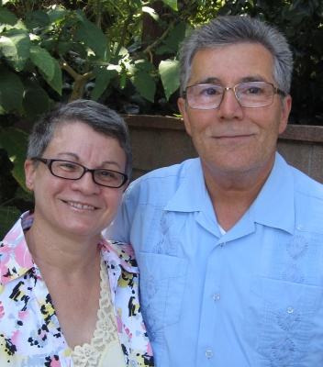
“We know that in all things God works for the good of those who love him, who have been called according to his purpose.” (Romans 8:28)
You can support our mission partnership with the Seminary and the Presbyterian-Reformed Church in Cuba. You can pray for us and our ministries. We invite you to make a gift to this ministry! You may send your check to: Presbyterian World Mission, P.O. Box 643700, Pittsburgh, PA 15264-3700. On the memo line, please write ‘Cortes – E200519’ (individuals) or ‘Cortes – D507587’ (congregations). Churches are asked to send contributions through your congregation’s normal receiving site. You may also make a gift online by visiting our giving link at: presbyterianmission.org/donate/E200519.
Rev. David Cortés-Fuentes
Josey Sáez Acevedo
Presbyterian Church (U.S.A.), 100 Witherspoon Street, Louisville, KY 40202

